Essay 1: UX & UI Analysis

The creation of a website is about more than just a user interface (UI) and its reliance on user experience (UX) design principles. Regardless of how a website piques your interests and how engaged you feel, a designer must always ensure that the interaction between the user interface and user acceptance is ethical. It is important to consider user accessibility as well. WebAIM (2021) claims that the elements of accessibility are measured against how the website is perceived, operated, and understood, with a level of robustness. In the UI and UX world, this is known as “POUR”. According to Rousi et al (2020), technology ethics focuses on how particular technologies can be used for good or bad.

To consider the interaction between UI, UX and ethics, Barševska and Rakele (2019) are of the opinion that one should first understand what these mean in relative terms. Barševska and Rakele (2019) further state that the user interface can be defined as elements such as buttons, text, images, sliders, and other interactive components in a website. This includes the layout of the screen, transition effects, interface animations and all forms of user interaction that will take place once a website is being used, which means it demands careful design attention. (Barševska & Rakele, 2019)

Appelquist et al (2023) state that intuitive user-friendly interfaces speak to the heart of the design process and will always enhance user experience*.* On the other hand, Koroveshi (2023) explains that user experience aims to develop visually appealing designs that will fit with the targeted audience, emphasising the significance of designing appealing and effective interfaces specifically for user requirements and preferences.

“Ethical web design refers to the practice of creating websites that adhere to moral principles, focusing on user well-being, accessibility, privacy, and fairness. It goes beyond aesthetics and functionality, embedding ethical considerations into every aspect of the design process.” (Appelquist, et al., 2023). In an age where the digital age is pivotal, ethical web designs ensure that websites serve the greater good, respecting users’ rights and providing equal access to information and services.

We have now established the importance of UI, UX, and ethics; and their relation to each other and their definitions. User interface and user experience are important for the creation of digital products, which blend functionality with aesthetics, to enhance the user’s satisfaction and engagement with the digital products. According to Fowler (2019), analysing user interface and user experience will make us aware of the various ways in which we should design and how we should behave when using technology.

The websites to be compared and analysed in terms of UI, UX, and ethics are *Steers*, a well-known and established fast food chain with online commerce on the open web and an application capability. At first glance, the website is functional, colourful, readable, interactive, and informative. The second website, *And Then There Was Fire*, is an upmarket restaurant which offers fine dining in an open-air art gallery with online booking capability. At first glance, the website has a modern aesthetic with understated colours, elegant fonts, and interactive capability.

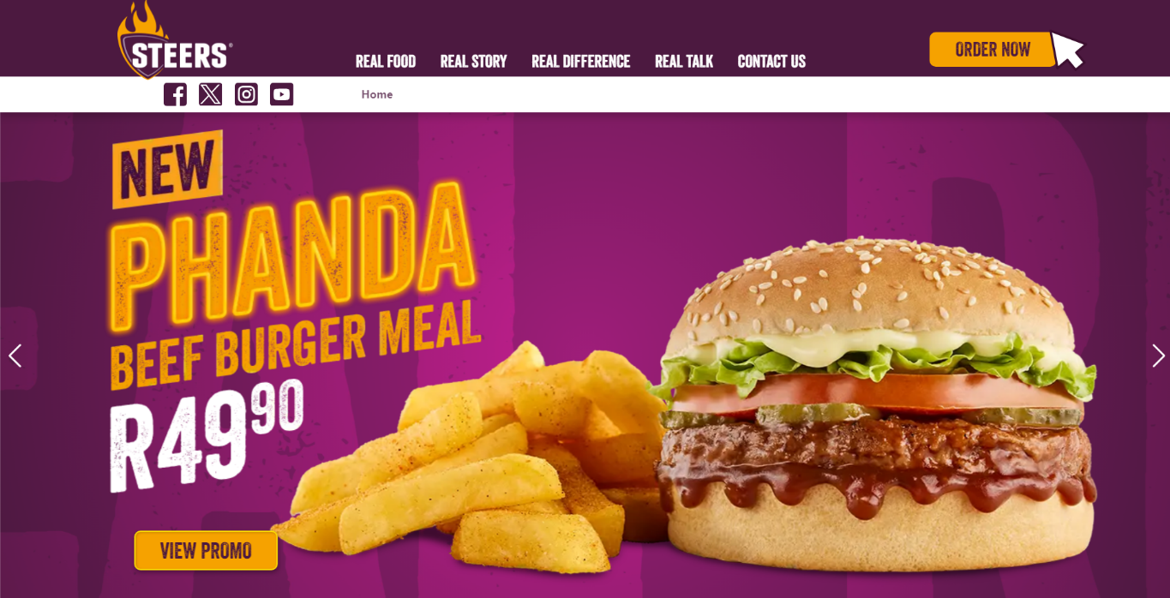

 The *Steers* website uses vibrant colours, with legible fonts which catch the user’s attention instantly, and by definition, make it accessible and operational by the target user. The website leaves no negative space with videos and multiple photos showcasing the food filling the screen. It is interactive with many animated buttons which change size once the user’s mouse hovers over them and has many different pages to explore, such as a promotions page, a halaal menu page, a contact page, and many more. Religious food information such as indicators of halaal and kosher as well as dietary information such as vegan or vegetarian are added to ethically responsible websites.

The content is unambiguous and straightforward regarding price and product. Products are arranged from the cheapest to most expensive options, thereby eliminating the possibility of accidentally ordering an item that is too expensive. All elements on the website are located where you expect them to be, adding to a user-friendly intuitive website. Their ‘Policy’, ‘Real Promise’ and ‘Contact Details’ are easily found at the bottom of the first page and the links are operational. Koroveshi (2023), emphasises multiple factors involved in user interface and user experience designs, highlighting the focus on colour. Designers utilise colour to accentuate the layout and structure, ensuring the platform or digital product is visually appealing whilst balancing the interface's aesthetic and functionality. Koroveshi (2023), states that designers usually incorporate colour into their work, adapting to preferences and popular colour schemes to their advantage. The *Steers* website has not undergone major changes or rebranding for years, this adds to a sense of comfort and familiarity. It has clear entry points, headings, and tabs.

A well-designed user interface creates an immersive experience, although users may not always be aware of their engagement with the website. According to Wood (2014), when a website’s user interface is thoroughly designed, the users will experience subconscious enjoyment.  If we look at the *Steers* website, it has multiple pages for users to read through with colourful labels and encourages users to explore the website more thoroughly.

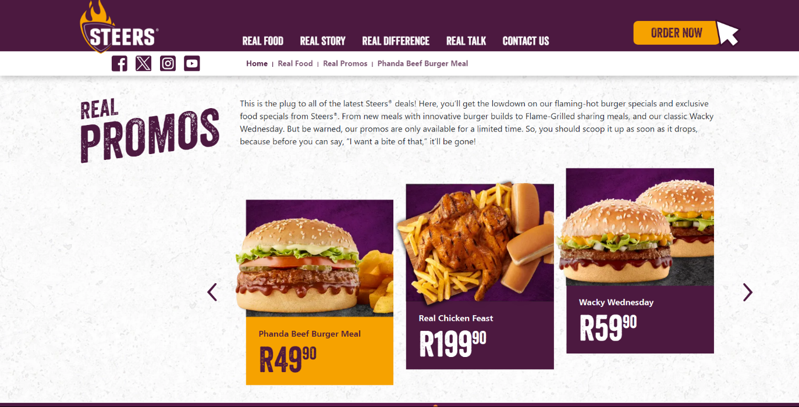

Wood (2014), describes that semiotics serve as a foundational concept when designing an interface and creating effective visual communication, emphasizing the relation between what the user sees (the signifier) and its intended meaning (the signified). *Steers*’ website is a perfect example of the effective use of semiotics. Wood (2014) further explains that incorporating semiotics into the user interface design is crucial, missing a specific visual element in your design can lead to misinterpretations and communication errors.

Colour and visuals hold great significance when designing for children and teenagers compared to adults. According to Bilham (2022), interfaces should have the ability to immerse a user in an exciting world or evoke certain emotions that will fuel their imagination. Therefore, embracing accessible and vibrant colours, as well as integrating images, can establish a cheerful and inviting environment to engage young users. Furthermore, Bilham (2022) underlines the importance of selecting child-friendly fonts. Fonts such as Futura, Sofia Pro Soft and Gill Sans Infant are examples of easily readable, soft fonts, suitable for everyone.



Aesthetics plays a significant role across various design principles; designers are consistently aiming to improve the visual appeal of websites to better their chances of becoming successful. Koroveshi (2023), indicates that as society progresses, there is a noticeable trend towards greater aesthetic trends, evident in the spread of visually attractive things, ranging from home decor to more visually pleasing cars.  This highlights the general influence of aesthetics in our surroundings, even if we don’t always notice it.

In terms of readability, Koroveshi (2023), opines that designers must prioritise the effectiveness of text presentation, ensuring that the text is easily readable to users. This involves choosing text colours that contrast well with the background colour, creating clear comprehension for readers. On the *And Then There Was Fire* website, as users scroll down, the small white text and Courier New font blend into the background when it is in front of a specific colour. The text on the website is difficult to read even when the background colour does not influence the readability of the text, as the size of the font they have chosen for the website is small. Koroveshi (2023), states that readability serves as an inclusive approach which enables users, including those who are colourblind or have impaired vision, to navigate the design effortlessly. By designing with these considerations in mind, Koroveshi (2023), claims that the website offers an enjoyable experience for all users, fostering engagement and accessibility.

The menu on the *And Then There Was Fire* website is a separate document with no bearing on the images in their gallery. Pricing is ambiguous and does not mention the entrance fee to the gallery, nor the booking fee of R100 per person. It is furthermore unclear whether the booking fee will be deducted from the final restaurant bill. This means that the user experience shifts from a positive to a negative opinion due to the hidden elements of the websites, the sense is that they are not ethical nor truthful in their offering and therefore other unethical factors may be experienced in the restaurant. No reference is made to religious or dietary options on their website, which results in the user being unclear on vegan, allergens and halaal selections.

Operationally there are links which are visible in the hierarchy but are difficult to find and allow no access due to broken links. There is no e-commerce, this is only for interactive booking on an online calendar. The user experience is poor and frustrating. Envisioning users’ real-time experiences is significant to user interface designers as it provides insight into their initial reactions to the digital product. However, while the visual appeal of the website is important, usability is just as important, ensuring that the digital product operates as it should to meet the users’ needs well. Although aesthetically pleasing designs may initially persuade users of a functional website, Koroveshi (2023), warns that usability issues may be overlooked, which usually leads to problems.

Wood (2014) indicates that once the user interface design introduces challenges, the flow becomes interrupted, abruptly pulling a user out of their immersion. To maintain a consistent flow, Wood (2014) claims that designers must consider asking fundamental questions such as: Does the user know how to navigate through the user interface? Can users efficiently complete their intended actions? Do users feel a sense of accomplishment after interacting with the website?

Colours can communicate distinct messages; however, the overall design and layout of the platform need to align with the various emotions communicated by these colours. Koroveshi (2023) is of the opinion that emotions offer numerous benefits when assessed, as they yield insights into user’s responses throughout their experience. Grieve (1991) claims that colours convey feelings, for example, the vibrant purple and orange colours on the *Steers* website can be associated with royalty and happiness, and the neutral beige and brown colours on the *And Then There Was Fire* website can be associated with warmth and kindness.

In conclusion, the elements of UI and UX transcend a mere “look and feel” experience, which includes the ethical design of a website. In preceding the analyses and comparison of the *Steers* and *And Then There Was Fire* websites the visually pleasing first impression of *And Then There Was Fire* is minimised by the poor user experience and small text. The bold and somewhat dated colours and aesthetic of the *Steers* website are elevated by the superior UX, it is clear that *Steers* gave much thought to their user interface as well as some ethical elements, which results in an intuitive, effective, and easy-to-use web design. Size does matter, and looks aren’t everything.

# References

Appelquist, D., Beeman, H. & Guy, A., 2023. *New Perspective Design.* [Online]   
Available at: https://www.newperspectivestudio.co.za/ethical-web-design-practices/

Aristotle, 1998. Nicomachean Ethics. *Clarendon Press.*

Barševska, Z. & Rakele, O., 2019. Color in UI Design. *Proceedings of the 61st International Scientific Conference of Daugavpils University,* pp. 79-87.

Bilham, J., 2022. *8 Things to Consider When Designing for Children.* [Online]   
Available at: https://raw.studio/blog/designing-for-children/

Engelbart, D. C. & English, W. K., 1968. *A research center for Augmenteing Human Intellect.* California: Stanford Research Institute Menlo Park.

Fire..., A. T. T. W., 2024. [Online]   
Available at: https://www.andthentherewasfire.com/

Fowler, H., 2019. The Human-UX/UI Relation. *Texas A&M University.*

Grieve, K. W., 1991. Traditional Beliefs and Colour Perception. In: *Perceptual and Motor Skills.* s.l.:University of Sout Africa.

Koroveshi, P., 2023. The Impact of Colour Psychology in User Experience.

Rousi, R., Leikas, J. & Saariluoma, P., 2020. *Emotions in Technology Design: From Experience to Ethics.* s.l.:University of Jyväskylä.

Steers, 2024. [Online]   
Available at: https://steers.co.za/

WebAim, 2021. *Constructing a POUR Website.* [Online]   
Available at: https://webaim.org/articles/pour/

Wood, D., 2014. *Interface design: An introduction to visual communication in UI design.* s.l.:Bloomsbury Publishing.